**Longer Instructions for Install on Windows**

<https://github.com/eviltester/startUsingJavaJUnit/blob/master/speedrun_install_java_checklist.md>

* **Download Java**
* search for "download java sdk" (do not install the normal JRE from java.com)
  + <http://www.oracle.com/technetwork/java/javase/downloads/index.html>
  + Select Java SE Development Kit 8u181
    - Windows x64 🡪 [jdk-8u181-windows-x64.exe](http://download.oracle.com/otn-pub/java/jdk/8u181-b13/96a7b8442fe848ef90c96a2fad6ed6d1/jdk-8u181-windows-x64.exe)
    - <http://download.oracle.com/otn-pub/java/jdk/8u181-b13/96a7b8442fe848ef90c96a2fad6ed6d1/jdk-8u181-windows-x64.exe>
* **Install Java 8 SDK**
  + - Windows
* e.g. C:\Program Files\Java\jdk1.8.0_181
* add the Java "\bin" folder to the path if it hasn't been added e.g. C:\Program Files\Java\jdk1.8.0_181\bin
* create a JAVA_HOME environment variable while there for the root path e.g. C:\Program Files\Java\jdk1.8.0_181

Variable name: JAVA_HOME

Variable value: C:\Program Files\Java\jdk1.8.0_181\bin

* + - * some people add a JDK_HOME for the root path as well (I haven't done this)

Variable name: PATH

Variable value: C:\Program Files\Java\jdk1.8.0_181\bin

* + - check Java JDK installed by typing javac -version in a new command line
* To Uninstall old Java (i.e. JDK) versions
  + - <https://www.java.com/en/download/uninstalltool.jsp>
    - Agree to the Terms and conditions
* **Install Maven**
  + Download Maven <http://maven.apache.org/download.html#Installation>
  + Windows
    - Unzip maven to a directory (avoid one with spaces in it)
      * e.g. C:\maven_3_5_4
    - add C:\maven_3_5_4\bin to the PATH in System Variables

Variable name: PATH

Variable value: C:\maven_3_5_4\bin

* + - check installed by typing mvn -version into a new command window
    - Maven installation instructions:
      * <http://maven.apache.org/install.html>
* To check if everything is installed after installing Java 8 SDK and Maven, check the environment variables by displaying them on the console
  + - Windows
      * echo %JAVA_HOME%
      * echo %PATH%
* **Install IntelliJ**
  + download IntelliJ Community Edition from <https://www.jetbrains.com/idea>
  + Install it
  + Install instructions:
    - <https://www.jetbrains.com/help/idea/install-and-set-up-product.html>

How to run Windows console:

* Click Windows start button 🡪 All programs 🡪 Accessories 🡪 Command prompt

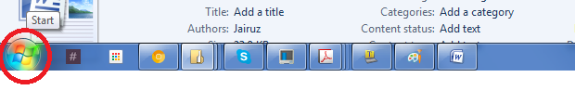

OR

* On the keyboard, type Windows button then “R” key (Windows + R) to open the Run command window\

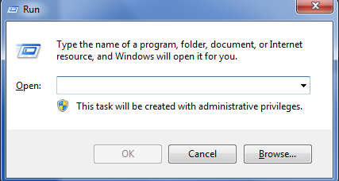

* Type **cmd** to run the console

